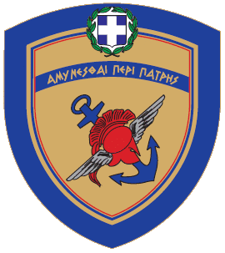
ΝΙΚΟΛΑΟΣ - ΓΕΩΡΓΙΟΣ Σ. ΔΕΝΔΙΑΣ
ΥΠΟΥΡΓΟΣ ΕΘΝΙΚΗΣ ΑΜΥΝΑΣ

ΠΡΟΣ: | ΒΟΥΛΗ ΤΩΝ ΕΛΛΗΝΩΝ  Δνση Κοινοβουλευτικού Ελέγχου Τμήμα Ερωτήσεων | ΥΠΟΥΡΓΕΙΟ ΕΘΝΙΚΗΣ ΑΜΥΝΑΣ ΓΡΑΦΕΙΟ ΝΟΜΟΘΕΤΙΚΗΣ ΠΡΩΤΟΒΟΥΛΙΑΣ ΤΜΗΜΑ ΚΟΙΝΟΒΟΥΛΕΥΤΙΚΟΥ ΕΛΕΓΧΟΥ  e-mail: nomgkbe@mod.mil.gr Φ.900α/1174/19126  Αθήνα, 24 Νοεμβρίου 2023  Σελίδες: Μία (1)
ΚΟΙΝ.: | Βουλευτή κ. Στυλιανό Φωτόπουλο
 | ΥΠΕΘΑ/Γραφείο ΥΕΘΑ
 | ΥΠΕΘΑ/Γραφείο ΥΦΕΘΑ
 | ΥΠΕΘΑ/Γενικός Γραμματέας
 | ΥΠΕΘΑ/ΓΝΠ/ΤΚΕ
ΥΠΕΘΑ/ΔΝΣΗ ΕΝΗΜΕΡΩΣΗΣ ΥΠΟΥΡΓΕΙΟ ΕΞΩΤΕΡΙΚΩΝ/
Τμήμα Κοινοβουλευτικού Ελέγχου
ΘΕΜΑ: | Κοινοβουλευτικός Έλεγχος
ΣΧΕΤ.: | Ερώτηση 1763/15-11-2023 της Βουλής των Ελλήνων

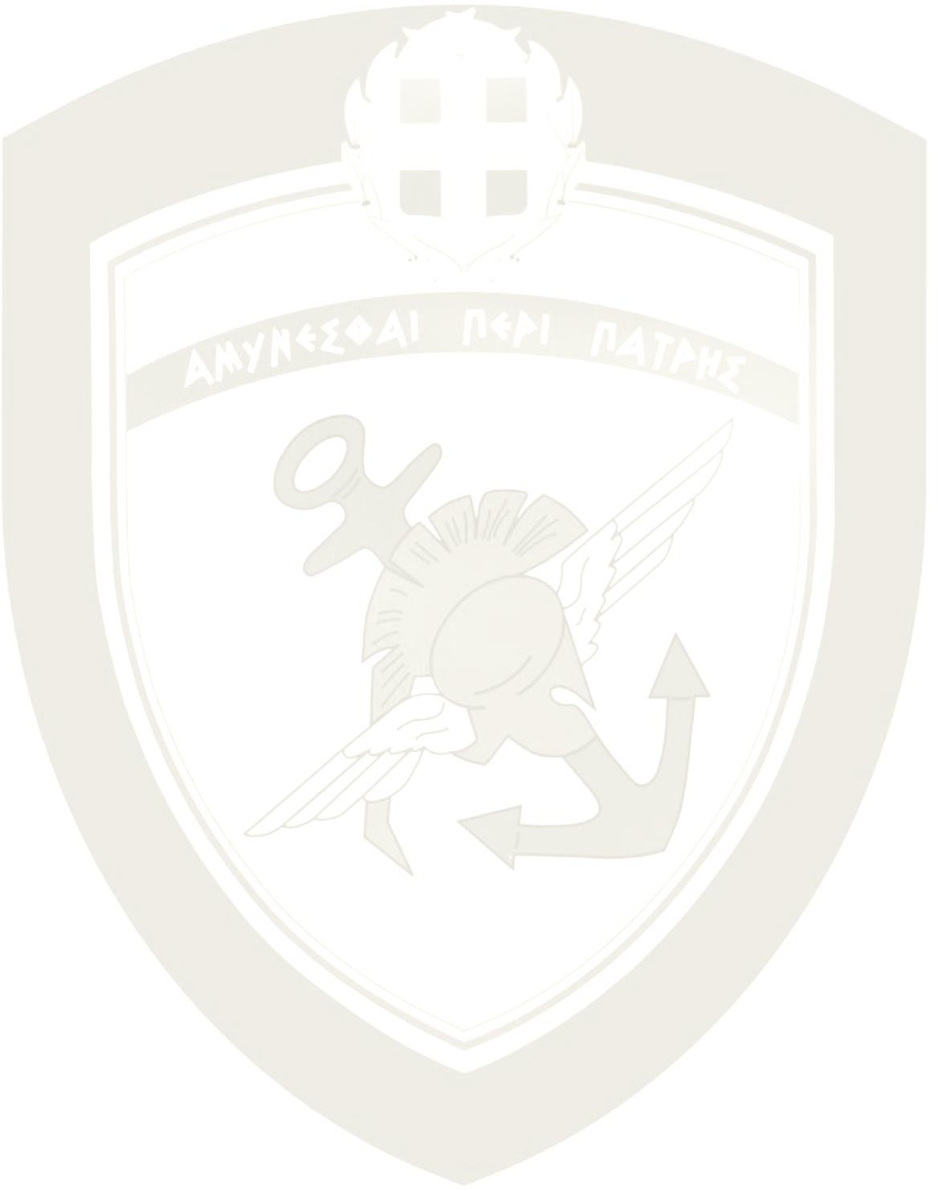./.

Σε απάντηση της σχετικής Ερώτησης, σας γνωρίζω τα ακόλουθα:
Με αφορμή τις εορταστικές εκδηλώσεις για τα 111 χρόνια από την απελευθέρωση της Χίου, διατυπώθηκε από την πλευρά μας η πάγια και σύμφωνη με το Διεθνές Δίκαιο θέση ότι η Χίος και όλα τα νησιά του Ανατολικού Αιγαίου απολαμβάνουν τα κυριαρχικά δικαιώματα, που απορρέουν από το Διεθνές Δίκαιο, δηλαδή έχουν Υφαλοκρηπίδα, Αποκλειστική Οικονομική Ζώνη (ΑΟΖ) και Χωρικά Ύδατα έως 12 ναυτικά μίλια, γεγονός που καταδεικνύει την προσήλωση της Χώρας στο Διεθνές Δίκαιο και ενισχύει την αποφασιστικότητα του Ελληνικού Λαού για προάσπιση των ελληνικών κυριαρχικών δικαιωμάτων.
Κατά τα λοιπά αρμόδιο να σας απαντήσει είναι το συνερωτώμενο Υπουργείο.
Digitally signed by VASILEIOS KOLIOPOULOS Date: 2023.11.27 14:26:00 EET

